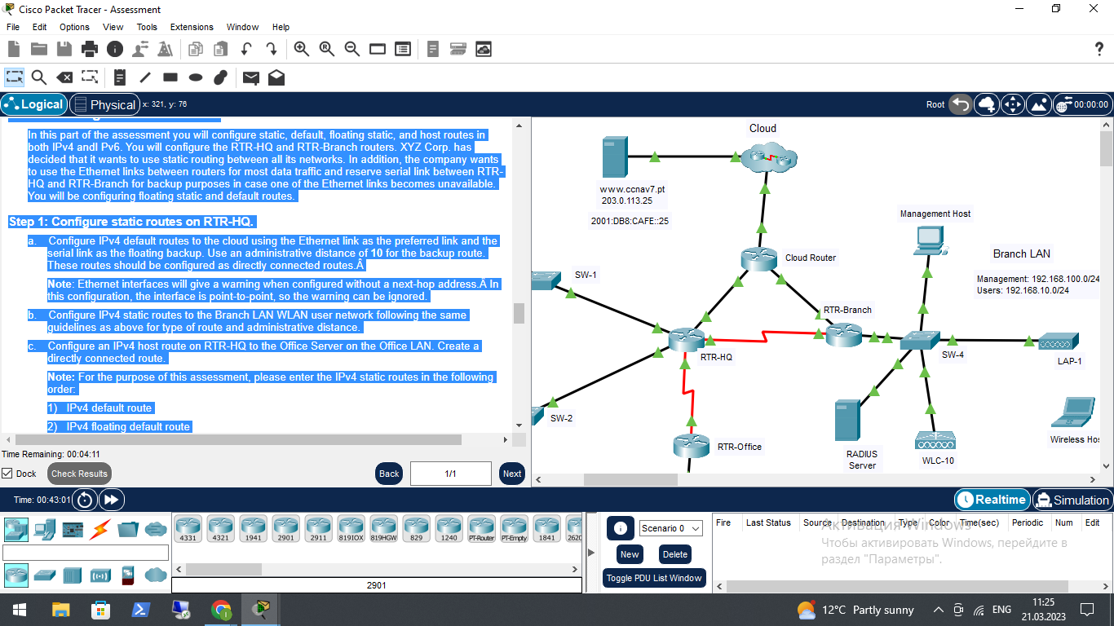

CCNAv7
Switching, Routing, and Wireless Essentials v7.0 (SRWE)
SRWE Practice PT Skills Assessment (PTSA) - Part 2

A few things to keep in mind while completing this activity:
- Do not use the browser Back button or close or reload any exam windows during the exam.
- Do not close Packet Tracer when you are done. It will close automatically.
- Click the Submit Assessment button in the browser window to submit your work.
Addressing Table
Device | Interface | Address and Prefix
RTR-HQ | G0/0/0 | 192.168.1.1/24
RTR-HQ | G0/0/0 | 2001:db8:acad:1::1/64
RTR-HQ | G0/0/0 | fe80::1
RTR-HQ | G0/0/1 | 192.168.2.1/24
RTR-HQ | G0/0/1 | 2001:db8:acad:2::1/64
RTR-HQ | G0/0/1 | fe80::1
RTR-HQ | G0/0/2 | 10.1.0.1/30
RTR-HQ | G0/0/2 | 2001:db8:acad:a::1/64
RTR-HQ | G0/0/2 | fe80::2
RTR-HQ | S0/1/0 | 10.2.0.1/30
RTR-HQ | S0/1/0 | 2001:db8:acad:b::1/64
RTR-HQ | S0/1/0 | fe80::2
RTR-HQ | S0/1/1 | 10.4.0.1/30
RTR-HQ | S0/1/1 | 2001:db8:acad:d::1/64
RTR-Office | S0/1/1 | 10.4.0.2/30
RTR-Office | S0/1/1 | 2001:db8:acad:d::2/64
RTR-Office | S0/1/1 | fe80::2
RTR-Office | G0/0/0 | 192.168.3.1/24
RTR-Office | G0/0/0 | 2001:db8:acad:3::1/64
RTR-Office | G0/0/0 | fe80::1
RTR-Branch | G0/0/0.10 | 192.168.10.1/24
RTR-Branch | G0/0/0.100 | 192.168.100.1/24
RTR-Branch | G0/0/0.172 | 172.16.1.1/24
RTR-Branch | G0/0/1 | DHCP
RTR-Branch | G0/0/1 | 2001:db8:acad:c::2/64
RTR-Branch | S0/1/0 | 10.2.0.2/30
RTR-Branch | S0/1/0 | 2001:db8:acad:b::2/64
Cloud Router | G0/0/0 | 10.1.0.2/24
Cloud Router | G0/0/0 | 2001:DB8:ACAD:A::2/64
Cloud Router | G0/0/1 | 10.3.0.1/24
Cloud Router | G0/0/1 | 2001:DB8:ACAD:C::1/64
WLC-10 | management | 192.168.100.254
WLC-10 | WLAN 10 | 192.168.10.254/24
Office Server | NIC | 192.168.3.122
Office Server | NIC | 2001:db8:acad:3::122
Web Server | NIC | 203.0.113.25
Web Server | NIC | 2001:db8:acad:cafe:25
DNS Server | NIC | 198.51.100.163
DNS Server | NIC | 2001:DB8:face::163
Management Host | NIC | 192.168.100.23
Wireless Host | NIC | DHCP
RADIUS server | NIC | 172.16.1.100/24
Host 1 | NIC | 192.168.1.10/24
ERROR: VARIABLE NOT FOUND [[Host 1_name]] | NIC | 2001:db8:acad:1::10/64
Host 2 | NIC | 192.168.1.11/24
ERROR: VARIABLE NOT FOUND [[Host 2_name]] | NIC | 2001:db8:acad:1::11/64
Host 3 | NIC | 192.168.2.20/24
ERROR: VARIABLE NOT FOUND [[Host 3_name]] | NIC | 2001:db8:acad:2::20/64
Host 4 | NIC | 192.168.2.11/24
ERROR: VARIABLE NOT FOUND [[Host 4_name]] | NIC | 2001:db8:acad:2::21/64
Host 5 | NIC | 192.168.3.30/24
ERROR: VARIABLE NOT FOUND [[Host 5_name]] | NIC | 2001:db8:acad:3::30/64

Objectives
In this assessment, you will configure the following:
 Floating static and default routes in IPv4 and IPv6.
 Host routes in IPv4 and IPv6.
 DHCP pools and scopes.
 Switch security including port security.
 Enhanced LAN security with DHCP snooping, dynamic ARP inspection, PortFast, and BPDU guard.
 Wireless LAN Controller-based wireless LAN with enterprise authentication.
You will only configure the RTR-HQ and RTR-Branch routers, the SW-1 switch, and the WLC-10 wireless LAN controller. Access to other devices is not available.
Background / Scenario
XYZ Corp. is reworking their network. You have been asked to prototype the network in Packet Tracer for evaluation by senior network staff.
Instructions
Part 1: Configure Switch Security
In this part of the assessment you will configure switch SW-1 with switch security features. Switch ports FastEthernet0/1 to FastEthernet0/5 are the active switch ports. Port GigabitEthernet0/1 is a dedicated link to router RTR-HQ. All other ports should be secured.
Step 1: Configure VLANs
a. Configure VLAN 10 with name users.
b. Configure VLAN 999 with the name unused.
Step 2: Configure active switch ports.
On the active switch ports configure the following:
a. Configure FastEthernet 0/1 through 0/5 and GigabitEthernet 0/1 as static access ports in VLAN 10.
b. Activate port security on the ports.
1) Configure the active ports to accept a maximum of 4 MAC addresses.
2) If a violation occurs, configure the ports to drop frames from the unauthorized MAC address, log it, and send an alert.
3) MAC addresses should be present in the MAC address table for a maximum of 10 minutes before they are removed.
4) Ports should add the learned MAC addresses to the running configuration.
5) Configure the MAC address of Host 1 as a static address on port FastEthernet0/1.
c. Protect against DHCP snooping.
Note: In this simulated network, DHCP snooping may not operate correctly in Packet Tracer. Configure it as you would normally. You will receive full credit for a configuration that meets the requirements below.
1) Activate DHCP snooping globally.
2) Activate DHCP snooping for the two VLANs that you configured.
3) Configure the ports to limit the rate to 5 DHCP packets per second.
4) Configure the port that links to the router as trusted.
d. Guard against ARP attacks by implementing DAI.
1) Activate DAI globally.
2) Activate DAI on the two VLANs.
3) Configure the port that links to the router as trusted.
e. Mitigate STP attacks by configuring BPDUguard and PortFast on the active ports.
Step 3: Secure unused switch ports.
a. Move all unused switch ports to VLAN 999.
b. Configure all unused switch ports as static access ports.
c. Deactivate all unused switch ports.
Part 2: Configure Addressing and DHCP
You will configure DHCP and interface addressing on router RTR-Branch to prepare for implementing the wireless LAN controller network.
Step 1: Configure and address a subinterface for the WLAN user network.
a. Configure subinterface 10 on the router interface that is connected to the switch SW-4.
b. The router should provide router-on-a-stick routing to VLAN 10.
c. Configure the subinterface with the address from the Addressing Table.
Step 2: Configure a DHCP pool for WLAN user network.
- Exclude the router interface address and the management address of the WLC.
R2(config)# ip dhcp excluded-address 192.168.10.1 192.168.10.10
b. Configure a DHCP pool that will be used by hosts that are connecting to the WLAN.
1) Name the pool WLAN-hosts.
2) Configure the pool to use addresses in the 192.168.10.0/24 network.
3) The pool should also provide the default gateway and DNS server addresses.
R2(dhcp-config)# network 192.168.10.0 255.255.255.0
R2(dhcp-config)# default-router 192.168.10.1
R2(dhcp-config)# dns-server 192.168.20.254
Step 3: Configure an interface as a DHCP client.
On RTR-Branch, configure the interface that is connected to Cloud Router to receive its address over DHCP.
R2(config)# interface g0/1
R2(config-if)# ip address dhcp
R2(config-if)# no shutdown
R2# show ip dhcp binding
Part 3: Configure Static Routes
In this part of the assessment you will configure static, default, floating static, and host routes in both IPv4 andI Pv6. You will configure the RTR-HQ and RTR-Branch routers. XYZ Corp. has decided that it wants to use static routing between all its networks. In addition, the company wants to use the Ethernet links between routers for most data traffic and reserve serial link between RTR-HQ and RTR-Branch for backup purposes in case one of the Ethernet links becomes unavailable. You will be configuring floating static and default routes.
Step 1: Configure static routes on RTR-HQ.
a. Configure IPv4 default routes to the cloud using the Ethernet link as the preferred link and the serial link as the floating backup. Use an administrative distance of 10 for the backup route. These routes should be configured as directly connected routes.Â
Note: Ethernet interfaces will give a warning when configured without a next-hop address.Â In this configuration, the interface is point-to-point, so the warning can be ignored.
b. Configure IPv4 static routes to the Branch LAN WLAN user network following the same guidelines as above for type of route and administrative distance.
c. Configure an IPv4 host route on RTR-HQ to the Office Server on the Office LAN. Create a directly connected route.
Note: For the purpose of this assessment, please enter the IPv4 static routes in the following order:
1) IPv4 default route
2) IPv4 floating default route
3) IPv4 host route
4) IPv4 static route to Branch LAN
5) IPv4 floating static route to Branch LAN
d. Ensure that the device is configured to route IPv6.
e. Configure IPv6 default routes to the cloud. Use the Ethernet link as the primary route, and the serial link as the floating backup. Use an administrative distance of 10 for the backup route. These routes should specify the next hop interface address.
f. Configure an IPv6 host route on RTR-HQ to the Office Server on the Office LAN It should be a next-hop route.
Note: For the purpose of this assessment, please enter the IPv6 static routes in the following order:
1) IPv6 default route
2) IPv6 floating default route
3) IPv6 host route
Step 2: Configure static routes on RTR-Branch.
RTR-Branch must also be configured with static routes to the other three networks in the XYZ Corp. network. It will require floating static and default routes in IPv4 and IPv6 following the same guidelines as were used for the RTR-HQ static routes.
o IPv6 routes use next-hop address arguments.
o IPv4 routes use exit interface arguments.
o All routes should prefer the Ethernet links over the serial link.
o Backup floating routes use an administrative distance of 10.
a. Configure IPv4 default routes to the cloud using the Ethernet link as the preferred link and the serial link as the backup.
Note: For the purpose of this assessment, please enter the IPv4 static routes in the following order:
1) IPv4 default route
2) IPv4 floating default route
b. Ensure that the device is configured to route IPv6.
c. Configure IPv6 default routes to the cloud. Use the Ethernet link as the primary route, and the serial link as backup. Use an administrative distance of 10 for the backup route. These routes should specify the next hop interface address.
Note: For the purpose of this assessment, please enter the IPv6 static routes in the following order:
1) IPv6 default route
2) IPv6 floating default route
Part 4: Configure a Wireless LAN using a Wireless LAN Controller
In this part of the assessment, you will configure the wireless LAN controller to provide access wireless access to the network. Username and password are the default admin/admin. Connect to the WLC over HTTPS to the management interface.
Step 1: Configure a VLAN interface.
a. Create a new interface and name it WLAN 10. The interface should use VLAN 10 and physical port 1.
b. Use the information in the addressing table to configure the addressing settings for the interface. The interface will be using a DHCP pool that is configured on the subinterface that is assigned to VLAN 10 on router RTR-Branch.
Step 2: Configure a RADIUS server.
a. Configure the WLC with the RADIUS server IPv4 address.
b. Use a shared secret of RADsecret.
Step 3: Configure a Wireless LAN.
a. Create a new WLAN. Name it WLAN 10 and configure the SSID as SSID-10.
b. The wireless LAN should use the VLAN interface that was previously configured.
c. Configure the WLAN to use the WPA2 security policy and dot1x Authentication Key Management.
d. Configure the WLAN to use the RADIUS server that was previously configured to authenticate wireless users.
e. Open the Advanced tab and scroll down to the Flexconnect sections. Activate FlexConnect Local Switching and FlexConnect Local Auth.
f. Verify that the WLAN is configured and operational.
Step 4: Configure a DHCP scope for the management network.
Configure a new DHCP scope to be used by the LAPs and other management devices on the network.
a. Name the DHCP scope Wired_Admin.
b. Start the scope at address 192.168.100.240. End the scope at address 192.168.100.249.
c. Other information that is required can be found in the Addressing Table.
Step 5: Configure an SNMP server.
Configure an SNMP server to receive traps from the WLC.
a. Use the community name branch-wireless.
b. Use 172.16.1.100 as the server address.
Step 6: Configure the wireless host.
Configure the Wireless Host to connect to the WLAN.
a. Create a new wireless profile on the host. Use the name work net for the profile.
b. Configure the profile for the SSID of the WLAN.
c. Use enterprise authentication with a username of user1 and password of user1Pass.
d. When you are finished, click Connect to Network. It will take time for the connection to be established.

ID: 0
Last updated January 2021.
Version 2.0
Created in Packet Tracer 7.3.1 and Marvel 2.0.7
All contents are Copyright 2021 Cisco Systems, Inc. All rights reserved. This document is Cisco Public Information.

